**COURSE: POST GRADUATE DIPLOMA IN WASH**

**ASSIGNMENT: No 1**

**ONLINE STUDIES, Netherlands**

**ADMISSION NUMBER: 340/06/2019**

**STUDENT NAME: MATUR SAMUEL AHOU**

**COUNTRY: SOUTH SUDAN**

**ORGANISATION: CSDO IN PARTNERSHIP WITH WATER FOR LAKES**

**TITLE: WASH FACILITATOR**

**Assignment 2**

1. Consider a disease known as diabetes mellitus, which is characterized by an increase in the blood sugar level. Infectious agents may contribute to the development of the disease in early childhood, but are not the main cause of the disease. Can it be classified as communicable? Explain your reasons

Answer: Diabetes is one of the four major types of non-communicable diseases (cardiovascular disease, diabetes, cancer and chronic respiratory diseases). It is a chronic condition that occurs when the body either does not produce enough insulin or cannot effectively use the insulin it does produce. Insulin is a hormone that regulates the blood sugar (glucose) formed from the food consumed by a person. Diabetes therefore results in raised blood sugar levels which, if not controlled, over time lead to serious damage to many of the body's systems.

Diabetes mellitus can be classified as non-communicable disease, reason that it cannot be cause by infectious agents and are not been transmitted between people.

1. How would you classify pulmonary tuberculosis using the epidemiologic method? What is the main importance of such classification?

Answer: Pulmonary tuberculosis is classified epidemiologically as an airborne disease. Such classification helps you in applying prevention and control measures against the disease.

1. Describe four or more bacterial vaccine-preventable diseases that have the same modes of transmission.

Answer: The four bacterial vaccine-preventable diseases are as follows; Tuberculosis, Meningitis (infection of the brain or spinal cord), Pertussis, and Pneumonia (infection of the lungs) with their modes of transmissions and are the commonest and the most important bacterial vaccine-preventable diseases in developing country.

* **Tuberculosis:** Tuberculosis (TB) is a disease caused by bacteria called Mycobacterium tuberculosis. The bacteria usually attack the lungs, but they can also damage other parts of the body. TB is spread from person to person through the air.

**Mode of transmission**

When people with lung TB cough, sneeze or spit, they propel the TB germs into the air. A person needs to inhale only a few of these germs to become infected.

* **Meningitis:** Meningitis is an infection of the brain and spinal cord by the bacterium Neisseria meningitis (also known as the meningococcal bacterium). The disease is caused by several groups of meningococuss bacteria, which are given distinguishing codes such as type A, B, C, Y, and W135.

**Mode of transmission and clinical symptoms:**

Meningococcal meningitis is transmitted to a healthy person by airborne droplets from the nose and throat of infected people when they sneeze or cough. The disease is marked by the sudden onset of intense headache, fever, nausea, vomiting, sensitivity to light and stiffness of the neck. Other signs include lethargy (extreme lack of energy), coma (loss of consciousness), and convulsions (uncontrollable shaking, seizures). *The* general *signs of meningitis, which may also be caused by some other serious conditions, and the more* specific *signs which are characteristic of meningitis.*

* **Pertussis:** pertussis is a bacterial disease caused by Bordetella pertussis.

**Mode of transmission:**

Pertussis is transmitted from person to person through sneezing and coughing by droplets from the nose and mouth of infected people.

* **Pneumonia (infection of the lungs):** pneumonia is a bacterial disease caused by streptococcus pneumonia. The term “pneumococcal disease” refers to a group of clinical conditions caused by the bacterium Streptococcus pneumonia. Invasive pneumococcal infections include pneumonia, meningitis and febrile bacteremia; the common non-invasive conditions include otitis media, sinusitis and bronchitis. Infection is acquired by direct person-to-person contact via respiratory droplets or oral contact. There are many healthy, asymptomatic carriers of the bacteria, but there is no animal reservoir or insect vector. Several chronic conditions predispose to serious pneumococcal disease (see below). Increasing pneumococcal resistance to antibiotics underlines the importance of vaccination

**Mode of transmission:**

Pneumonia is transmitted from person to person through sneezing and coughing by droplets of infected person from the nose and mouth.

1. What are the causes and methods for preventing bacterial meningitis?

Answer:

Causes of bacterial meningitis;

Bacterial meningitis is caused by several different types of bacteria, including:

* [Streptococcus pneumoniae](https://www.healthline.com/health/bacterial-pneumonia), also called pneumococcus
* [Neisseria meningitidis](https://www.healthline.com/health/meningitis-meningococcal), also called meningococcus
* [Haemophilus influenzae](https://www.healthline.com/health/epiglottitis), also called Hib
* [Listeria monocytogenes](https://www.healthline.com/health/listeria-infection)
* [Group B strep](https://www.healthline.com/health/strep-throat)
* [E. coli](https://www.healthline.com/health/e-coli-infection)

**Strategies to prevent and control meningitis**

* Early identification and prompt treatment of cases in the health facility and in the community.
* Community health education on the symptoms of meningitis, the mode of transmission and the treatment of disease.
* Reporting any cases of meningitis to the primary health care center or Boma health office; and avoiding close contact with the sick persons. Your health education messages should tell everybody about the disease.
* Vaccination against meningococcus bacteria of types A, C, Y and W135

1. Explain two characteristics that illustrate how the Anopheles larvae are different from other mosquito larvae. Using illustration is advised

Answer:

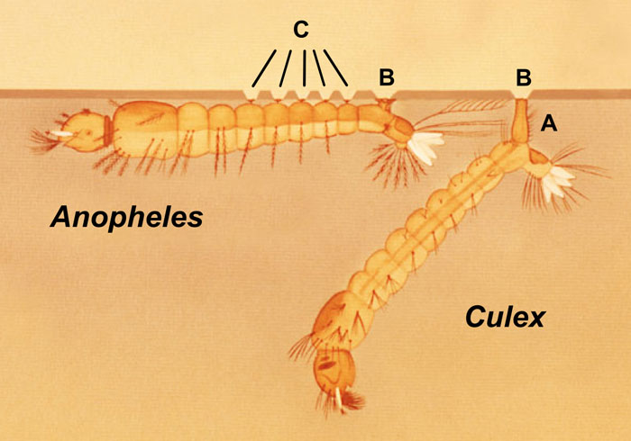

Rest at an angle to the water surface

Rest parallel to the water surface

Two characteristics that distinguish the Anopheles larvae from other types are:

The culicine larvae has a breathing tube (siphon) which it also uses to hang down from the water surface, whereas the anopheline larva has no siphon and rest parallel to and immediately below the surface.

**References:**

1. World Health Organization (WHO, 1997)
2. Center for Disease Control (2016, CDC)
3. The Open University, 2003 Infectious Disease, Book 5: Evolving Infections
4. Source: pocket Book of Hospital Care for Children, p.50
5. U.S. Agency for International Development Bureau for Global Health Office of Health, Infectious Diseases and Nutrition, 1300 Pennsylvania Ave Washington, DC 20523 [www.usaid.gov](http://www.usaid.gov)
6. WHO information on vaccine preventable diseases: http://www.who.int/immunization/en/WHO vaccine position papers: http://www.who.int/immunization/documents/positionpa-pers_intro/en/index.html